Torment Card Preview: Compulsion
Alex Shvartsman
Monday, January 7, 2002
Back in the days of Urza's Destiny, an enchantment called Mental Discipline was printed. It cost to cast, and allowed a player to discard a card in his hand for , then draw another card to replace it. Mental Discipline was not very exciting. It saw occasional play in Limited, but was not a high pick. Its brief cameo in Constructed was an appearance in some versions of Replenish decks, but it never caught on.
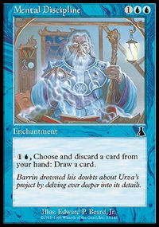
In Torment, R&D is taking another stab at the same mechanic. This time around though, the card they made just might make it to the big time - thanks to a few enhancements to its abilities and the mechanics available in Torment and Odyssey.
To start things off, Compulsion costs only . Although the difference is only a single mana point, that could make or break any card. With so many of the viable counterspells in the format costing three mana, you can often cast Compulsion on turn 2 instead of choosing to bluff holding an actual Counterspell. Even if you do not, you can get Compulsion into play sooner - leaving two or three mana untapped to counter whatever it is an opponent might want to do.
Another improvement is Compulsion's ability to cycle itself - the ability to sacrifice it in order to draw another card. With mana untapped, it is no longer an attractive target for Disenchant in Constructed, or Aven Cloudchaser in Limited. However, the ability is not as important as it could be on another type of card. Normally, this ability acts as a "reserve" - a card you can get rid of if you are in trouble and need to find an answer (such as Wrath of God) as quickly as possible. In this case however, you will be better served cycling cards until you find the right one - provided there are some in your hand.
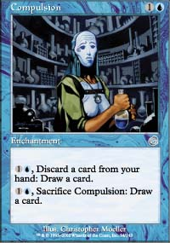
All that said, it is pretty clear that Compulsion is far superior to Mental Discipline. However, that isn't exactly what a card wants to put on its resume. I mean, who even remembers the Discipline? In fact, what makes Compulsion interesting is not so much the built-in improvements, but the mechanics of other cards in the format.
The major mechanic introduced in Odyssey was threshold. Players quickly learned that getting seven cards into their graveyard can be more difficult than it appears. Any card that lets you put cards in the graveyard without losing card economy is going to warrant a second look. The interaction with threshold is obvious - you can reach it in just a few turns, while setting up an excellent hand for yourself. Of more interest is interaction with madness - a brand new mechanic to be introduced in Torment.
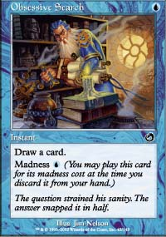
Madness cards have an alternative casting cost for which they can be played as they are being discarded. For example, Obsessive Search is an instant that lets you draw a card for . Inferior to Opt and Sleight of Hand? Perhaps, but it also has a madness cost of . Which means that if your opponent casts Ravenous Rats or attacks you with Blazing Specter, you can regain card economy by casting the Search as it is being discarded. You can combine madness cards with Compulsion to produce various effects - such as draw extra cards as with Obsessive Search, put a free creature into play, and more!
In Limited, Compulsion will not be a first pick quality card like Cephalid Looter. The two mana it requires to cycle a card are way too important early on in the game in order to develop the board by casting creatures, whereas Looter is a one-time investment of three mana. However, it will certainly see play and probably get drafted around 6th-9th pick. In Constructed, Compulsion may also see some play. It will not be the next Call of the Herd or Fact or Fiction, but it is certainly a card to consider when constructing your next deck.

